**Supply Chain Performance Report**

# Introduction

This report presents an in-depth analysis of supply chain performance based on key metrics displayed in the two-page dashboard. It focuses on revenue distribution, product availability, lead times, defect rates, and shipping performance. The goal is to identify strengths and weaknesses in the supply chain and provide actionable recommendations for improvement.

# 1. Revenue Analysis

The total revenue generated is **$578K** from **46K sold products**. However, an important insight emerges when we look at the breakdown by gender and product type: **female haircare products contribute only 2% of the total revenue**, while skincare and cosmetics have more balanced contributions across genders.

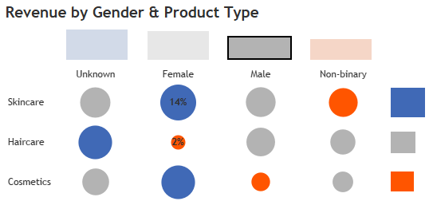

**Recommendation:**

Given the low revenue share for female haircare, there's an opportunity to explore whether the demand for female-targeted haircare products is being properly addressed or if marketing and product visibility strategies need improvement. Consider:

* Conducting market research to understand customer needs.
* Improving product visibility and promotions for female haircare.
* Exploring new product launches tailored to this segment.

# 2. Top and Bottom Products by Revenue

The **Top 10 Products** by revenue and the **Bottom 10 Products** show a significant revenue gap. SKU51, SKU38, and SKU90 lead the top products, whereas SKU91, SKU66, and SKU75 are the lowest-performing SKUs. This stark contrast suggests some products dominate sales while others lag behind.

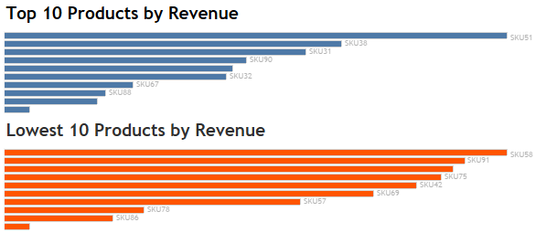

**Recommendation:**

Focus efforts on understanding why certain SKUs, particularly in the bottom 10, are underperforming. Consider:

* Reviewing stock levels and pricing.
* Conducting product performance reviews to decide if these SKUs should be discontinued or revamped.
* Enhancing promotions or bundling for underperforming SKUs to boost sales.

# 3. Product Availability

The **average availability** across all SKUs is **48%**, which is quite low and could result in lost sales opportunities. For example, SKU66 and SKU57 show the lowest availability. Ensuring better stock availability is crucial to meet demand.

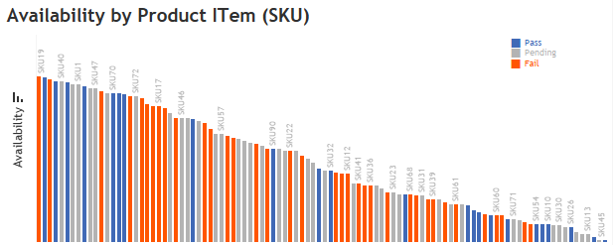

**Recommendation:**

Improving product availability is critical to maximizing sales:

* Analyze the supply chain process for products with low availability to identify bottlenecks.
* Work closely with suppliers to improve delivery times and stock replenishment.
* Introduce demand forecasting models to optimize inventory levels.

# 4. Revenue vs. Price by SKU

* The **Revenue vs. Price by SKU** scatter plot reveals that there is almost no strong correlation between price and revenue.
* **Conclusion**: The lack of a strong relationship between price and revenue suggests that other factors such as product type, marketing efforts, and availability might play more significant roles in determining sales performance.

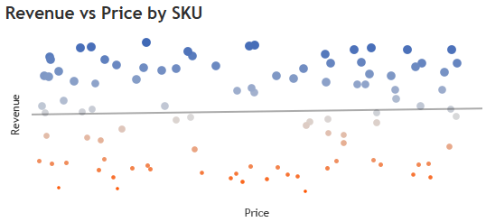

* **Recommendations**:
  1. **Dynamic Pricing Strategy**: Explore other pricing strategies that might boost revenue, such as bundling or seasonal discounts.
  2. **Focus on Product Differentiation**: Rather than solely adjusting prices, consider improving product features or differentiating them in the market.

# 5. Lead Time and Supplier Performance

The average **total lead time** is **49 days**, with **18 days for manufacturing lead time** and **6 days for shipping time**. Supplier S3 has notably higher lead times for cosmetics and skincare products, while S1 has better performance in both lead times and production volume.

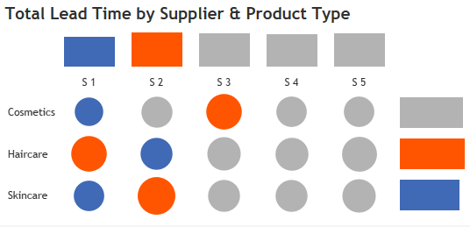

**Recommendation:**

Focus on improving lead times for suppliers with higher delays (like S3):

* Negotiate with suppliers for quicker production and shipping times.
* Consider switching to alternative suppliers with better lead time performance.
* Implement better planning and coordination to reduce overall lead times.

# 6. Defect Rate Analysis

The overall defect rate stands at **2.06%**, which is within acceptable limits. However, certain suppliers have higher defect rates, particularly S3 for haircare products and S5 for skincare.

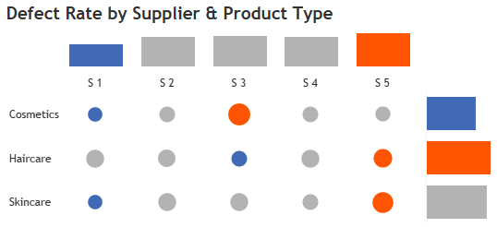

**Recommendation:**

To address higher defect rates:

* Implement stricter quality control measures with suppliers that have high defect rates (S3 and S5).
* Collaborate with these suppliers to understand and resolve the root causes of quality issues.
* Consider diversifying the supplier base to reduce reliance on underperforming suppliers.

# 7. Shipping Performance

The average **shipping cost** is **$5.90**, and **Carrier A** provides the best balance between shipping cost and time. Carriers B and C have higher costs for similar or longer shipping times, particularly for road and sea shipments.

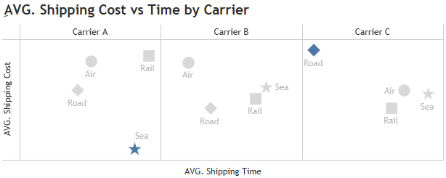

**Recommendation:**

To optimize shipping performance:

* Prioritize working with Carrier A, which provides the best cost-time ratio.
* Negotiate better shipping rates with other carriers or explore alternatives.
* Use different carriers for different regions or products based on performance.

# 8. Production Volume by Supplier

* The **Production Volume by Supplier** chart provides insights into how much each supplier is contributing to the overall production. Supplier 1 leads in production volume, while other suppliers contribute less significantly.

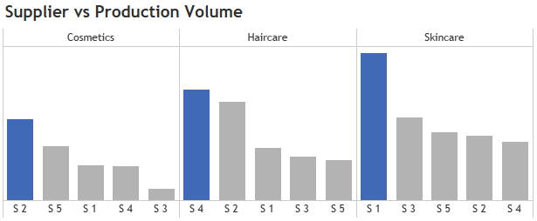

* **Observation**: Although Supplier 1 is the largest producer, it also has the longest lead times. This suggests that while they are a key contributor to supply, their inefficiency could be delaying product availability. On the other hand, suppliers with shorter lead times could be leveraged more effectively to balance supply.
* **Recommendations**:
  1. **Diversification of Production**: Consider increasing reliance on suppliers with shorter lead times, even if their production volume is lower, to ensure consistent product availability.
  2. **Supplier 1 Performance Improvement**: Collaborate with Supplier 1 to reduce their lead times, as they are critical to the supply chain due to their high production capacity. Improving their efficiency would have a significant positive impact on overall supply chain performance.

# Conclusion

The supply chain performance analysis reveals several opportunities for improvement:

* **Revenue growth**: There's significant potential to increase revenue from female-targeted haircare products.
* **Product availability**: Low availability is a concern and needs immediate attention to prevent lost sales.
* **Lead times**: Suppliers with longer lead times should be optimized or reconsidered to improve overall efficiency.
* **Defect rates**: Quality control must be enhanced for certain suppliers, especially those with higher defect rates.